CROSSWAY NETWORK
MINISTERIAL LICENSING
APPLICATION, POLICIES & PROCEDURES


CROSSWAY NETWORK MINISTERIAL LICENSING

CROSSWAY NETWORK MINISTERIAL LICENSING
CONTENTS

PART 1 – Licensing Policies and Procedures

PART 2 – Local Church Affirmation

PART 3 – Background Information

PART 4 – Crossway Network DNA

PART 5 – Doctrinal Statement

PART 6 – For Your Wife

PART 7 – For Church Adoption Candidates

To receive an editable MS Word file of this application, please email the Director of Licensing (see below). Please return this completed Application for Ministry Credentials to Crossway’s Licensing Team through your sponsoring or sending church.

Crossway Network
Att: Clark Richardson, Crossway Director of Licensing
700 Automation Dr, Unit D
Windsor, CO 80550
Email: clark@crosswaynetwork.org

PART 1
LICENSING POLICIES AND PROCEDURES

CANDIDATES FOR LICENSING
Crossway Network will grant ministry credentials to those who meet the requirements of the IRS for the role of “minister” as affirmed by their local church. This includes those ordained (or recognized) as pastors in their local churches, as well as others who meet the IRS requirements and have roles of ministry within their local churches, but who are not formally recognized as pastors. We encourage licensing for all pastors serving Crossway Network churches. Licensing with Crossway is required for lead pastors of established churches and for new Crossway church plants in the Network family.

LICENSING PROCEDURE
Those wishing to pursue credentials through Crossway Network will go through the following procedure. This includes both those who are pursuing licensing for the first time, as well as those wishing to switch credentials they currently hold through another organization:

- The endorsement of the candidate’s local church, including the affirmation that the individual currently meets the requirements of "minister" according to the IRS tax code as defined by that local church’s policies. See Part 2 below.
- An extensive theological and personal application to be submitted to the Licensing Team included below in Parts 3-5.
- A formal interview before the Crossway Licensing Team (spouse included) either in person or via video conferencing.
- Formal approval or denial from the Licensing Team

TERMS OF LICENSING
Licensing is intended only for those actively ministering within Crossway Network churches. Candidates who are in a process leading toward a long-term Crossway partnership may apply and be licensed as well. This will include pathways like church plant residencies, church adoptions, international church planting, and church revitalization. A ministerial license will be renewed automatically every two years. If a leader moves on to ministry outside of the Crossway Network, their ministerial license will not be renewed. If an extension is needed on the way to obtaining licensing through another agency, one can be requested. Extensions will be granted for one year with an evaluation of what may be needed going forward at the end of that year.

LICENSING TEAM
The Crossway Licensing Team will consist of three to five pastors from within the Crossway Network, with at least one who is also serving on the Crossway Servant Team. The Licensing Team members will be approved through yearly communication with the Crossway Network lead pastors. One of the Licensing Team members will serve as the Director of Licensing to schedule licensing interviews, maintain records, and distribute credentials for new and existing licensed Crossway pastors.

PURPOSE OF THE LICENSING TEAM
To uphold the theological convictions and integrity (DNA) of the Crossway Network as defined in “Crossway at a Glance” and the DNA Curriculum. Candidates will be expected to show a solid theological understanding and have the ability to represent their own views thoroughly and biblically. The team will also look into the character and practical ministry skills of the candidate, although they will trust and rely heavily on the local church who has recommended the candidate to the process in these areas.
PART 2
LOCAL CHURCH AFFIRMATION

All applicants for licensing must have the endorsement of the pastoral team of their local church. Please have a pastor from your church complete this section and include it when you submit your completed application. They are required to thoroughly review your completed application before you forward it to the Licensing Team.

PERSONAL INFORMATION

- Full Name of Applicant (First, Middle, Last):

- Your Full Name (First, Middle, Last):

- Cell Phone:

- Email:

- Name of Your Church:

- Names of all Members of Your Pastoral Team:

Within the application, there are many questions that probe into the character of the candidate. The questions are meant to give the Licensing Team a picture of the individual’s Christian experience and are helpful in keeping the licensing process in line with our Leadership Culture. While there may be observations and input, The Licensing Team does not decide on any official affirmation of a candidate’s character as a part of the interview process, but rather trusts the affirmation of their local church.

- I have read the applicant’s completed application, and I affirm that he has approached it with diligence, excellence, and care.

- This individual meets the requirements of "minister" according to the IRS tax code and is designated as such in our church’s documentation (not applicable for non-vocational pastors).

- On behalf of our entire pastoral team of our church, I affirm and endorse the character of this individual and recommend him for Crossway licensing.

Signature: Date:

______________________________________________ _______________________________________
PART 3
BACKGROUND INFORMATION

PERSONAL INFORMATION

  - Full Name (First, Middle, Last):

  - Address:

City, State, Zip:
Home Phone:
Cell Phone:
Email:

- Country of citizenship:

Status in U.S. if not a U.S. citizen:

- Marital status: Single Married Engaged Widowed

- If applicable, name of spouse or fiancée:

- Date of Anniversary:

- Have you ever been divorced? Has your spouse ever been divorced? If separated from spouse, divorced, remarried, or married to a divorced person, kindly give details.

- Is your spouse or fiancée on board with your desire for Christian service? Comments:

- Names and ages of children:

- Names of persons other than children dependent upon you for support. To what extent in each case?

- Do you have any debt? If yes, state nature and amount.

- Has your driver’s license ever been suspended or revoked?

- Have you been convicted of any criminal charges? If so, explain.

- Have you ever been a user of alcoholic beverages, narcotics, tobacco, marijuana, prescription drugs for non-medical purposes), or mind-altering drugs? Explain.

- What is your attitude toward alcohol and Christian freedom? If you consume alcohol, how often do you consume it, under what conditions, and how much? In a given week, how many times do you consume alcohol?

- Have you ever wrestled with unbiblical sexual activity, such as pornography, fornication, adultery, or homosexuality or experienced same-sex attraction or gender confusion? If so, please explain both the past and present nature of that struggle.
EDUCATION AND VOCATION

1. Colleges or seminaries attended: (Institution's Name, Major, Years, Graduation, Degree)
If you have quick access - Please provide a transcript of credits from each school listed

2. Other vocational training:

3. List any work experience:

4. Your present occupation:

Name of employer:
Address:
Telephone:
Contact Reference (name and phone):

CHRISTIAN EXPERIENCE

1. Date and place of conversion:

2. Upon what do you base your claim of salvation?

3. When and how were you baptized?

4. List other church or parachurch affiliations:

5. Are you currently licensed by, or have you ever been licensed by, a different organization? Provide details.

6. Write a brief story of your life including your personal testimony of salvation.

7. Briefly describe your current relationship with Jesus and your personal devotional habits.

8. Describe your current ministry involvement and what your passions are in ministry.

9. What ministry experiences have most shaped your spiritual maturity and your personal philosophy of ministry?

10. Describe the most difficult shepherding situation you have encountered in ministry? How did you handle the situation, and what did God teach you through it?

11. If married, please describe how you currently shepherd and lead your wife and family.

12. If married, how do you and your wife typically handle conflict?

13. Describe a time when the demands of ministry put a strain on your marriage or family life. What did God teach you through that and how have you responded?

PART 4
CROSSWAY NETWORK DNA

Crossway Network consists of like-minded churches who are in voluntary partnership around three key areas of distinction: Biblical Convictions, Ministry Philosophy, and Leadership Culture. These three areas give clarity and definition to what draws us together in ministry to plant churches. These form the “DNA” of our Network, and as such, it is critical that those licensed for ministry within Crossway share this DNA. SEE OUR DNA HERE (link in electronic copies).

IMPORTANT NOTE:
The aim of this application is for you to interact personally with the theology and DNA and to be deeply formed by it in the process. The primary goal is not to write down “the correct answers,” but to further establish your positions and evaluate your alignment with the Crossway Network. In light of that, we ask that you use only your own research and writing from either your past or current theological study. We ask that you not use AI tools in forming your answers apart from simple spelling or grammar checks.

- Why are you interested in being licensed under the Crossway Network umbrella?

- Have you read, and are you in agreement with the Biblical Convictions of Crossway as outlined in Part 1 of our DNA Curriculum? Do you have any reservations or areas of divergence? If so, please explain in detail?

- Have you read, and are you in agreement with the Ministry Philosophy of Crossway as outlined in part 2 of the DNA Curriculum? Do you have any reservations or areas of divergence? If so, please explain in detail?

- Have you read, and are you in agreement with the Leadership Culture of Crossway as outlined in Part 3 of the DNA Curriculum? Do you have any reservations or areas of divergence? If so, please explain in detail?

- Due to our “complementarian” view of men’s and women’s roles, we believe there is a restriction in 1 Timothy 2:12 of a woman not teaching or exercising authority over a man within the local church. In your understanding, what does this restriction mean practically? How would it influence the way you structure ministry?

- What roles in the church would you want to train and empower women for so that they are fully unleashed and enabled in their gifting for the benefit of the local church?

- Have you ever seen the church discipline process of Matthew 18 carried out in the local church? Describe the circumstances, the process, and the outcomes.

- Describe a time when you experienced genuine biblical community with others? How have you been used by God to reproduce that experience with others?

- What are the real tensions that come with trying to engage the lost and culture with the gospel? Describe how you have done this without compromising the gospel message?
- Describe the last time you explicitly shared the gospel with someone? Have you ever seen God use you to draw someone to faith? If so, share the story.

- Describe what it means to be “gospel-centered” as an individual and in ministry?

- Describe your understanding of “conversion growth” vs. “transfer growth” in the church. What have you seen historically in your local church and how would you like to see it improve?
- What is Biblical “plurality” when it comes to pastoral leadership?
- What is the Biblical support for the local church being led in plurality?

- Why is it important for the local church to be led in plurality? What are the blessings that come with having a plurality in the pastoral leadership? What are the liabilities when it is absent?

- As a pastor or leader, have you experienced leading in the context of plurality? Please describe your experience.

- Describe a time when another leader spoke into your life for the sake of your own growth and sanctification? How did you handle it? How did God use it in your life?

- Describe a time when you had to fight for unity with other leaders?

- Describe a time when you had to defer to another leader (or group of leaders) on a ministry decision being made?

- Describe a time when your pride as a leader impacted unity or ministry. What did God teach you through it? How do you fight for humility when working with other leaders?

PART 5
DOCTRINAL STATEMENT

Please provide your own doctrinal positions in summary form below. Include biblical references and enough detail to be clear, but do not attempt to cover every doctrinal topic so extensively that it becomes insurmountable.

- Summarize your biblical position on the doctrine of the divine inspiration of the scriptures.

- What is your belief concerning the Trinity?

- What is your belief regarding the deity of Christ? Why is this doctrine so vital?

- What is your belief regarding the virgin birth of Christ? Why is this doctrine so vital?

- What is your belief regarding the resurrection of Christ. Why is this doctrine so vital?

- How did humanity come into existence and what was our nature originally?

- What was the impact of the fall of Adam and Eve on humanity?
- What is the nature of unregenerate man?

- What divine provision has been made for man's redemption?

- How does someone receive salvation?

- Summarize your view on election and the sovereign grace of God in the salvation of people.

- Is it possible for a child of God to lose their salvation? Summarize your view on a person who seems to have embraced Christ by faith and later rejects the gospel.

- Define sanctification and explain its relationship with regeneration and spiritual growth.

- What is the role of “good works” in a believer’s life?

- What is the ministry of the Holy Spirit in and for the believer and what gifts does he bestow?

- State your position on the gift of tongues. In your answer, please also define your view on the nature of the baptism of the Holy Spirit and its relationship to the gift of tongues (if any).

- What manifestations of the Spirit other than the sign gifts are there?

- State your position on divine healing.

- Describe your understanding of Jesus 2nd coming and events surrounding the end times. What is your perspective on the millennium?

- When will the saved be resurrected? When, where, and for what purpose will the saved be judged?

- When will the unsaved be resurrected? When, where, and for what purpose will the unsaved be judged?

- What do you believe concerning the spiritual and eternal state of those who have never heard the gospel?

- What is the significance of baptism, who should participate, and what is the biblical mode of baptism?

- What is the significance of the Lord's Supper and who should participate?

- Is divorce ever permissible? If so, under what conditions?

- Is it permissible for a divorced person to remarry during the lifetime of the former spouse?

- Articulate a biblical view of the image of God in humanity. Explain how this view relates to contemporary debates about gender and sexuality.

- What are some of the possible causes of same sex attraction and/or gender dysphoria in people? How would you say faith in Christ and the hope of the gospel addresses the root causes?

- How would you respond biblically and pastorally to someone who claims to be a different gender from their biological sex?
- How would you respond biblically and pastorally to someone who claims that God blesses same sex relationships?

- What is your belief concerning a Christian's participation in and attitude toward civil government?

- What is God's plan concerning the purpose and ministry of the church?

- What role is the church to play in a believer’s life?

- What does the Bible teach about church discipline and restoration?

- What does the Bible teach about the leadership structure of the local church? What freedom does the local church have in terms of how it structures itself to carry out its mission?

- What does the Bible teach about men and women serving in the church? What practical restrictions do you see in terms of roles that women can play in serving in the church?

- How would you explain the unity of the scripture from start to end to someone? In other words, what is the storyline or overarching narrative of the Bible and how does that provide context for understanding individual passages of scripture?

- In your own words, what is “the gospel” and how does it relate to everyday ministry in the life of the church?

- In addition to the Bible, what authors, theologians, movements, or schools of thought have most influenced your theology?

- Do you have any theological or ministerial views that you perceive might be incompatible with Crossway based upon your current level of exposure to the Network?

The above is a concise statement of my doctrinal beliefs on all subjects referenced in all previous pages and was formed by my own prayerful study, research, and writing. I hereby apply for credentials as a minister with Crossway Network.

Signature: Date:

______________________________________________ _______________________________________

NOTE:

For all licensing applicants, please continue to Part 6, “For Your Wife” on the following page.

For those applying for a license as a part of the Crossway Adoption Pathway, please also continue to Part 7.

PART 6
FOR YOUR WIFE

PERSONAL INFORMATION

- Full Name (First, Middle, Last):

- Address:

City, State, Zip:
Home Phone
Cell Phone:
Email:

- Country of citizenship:

Status in U.S. if not a U.S. citizen:

- If previously divorced, kindly give details.

- Describe your support for your spouse’s desire for Christian service.

- Has your driver’s license ever been suspended or revoked?

- Have you been convicted of any criminal charges? If so, explain.

- Have you ever been a user of alcoholic beverages, narcotics, tobacco, marijuana, prescription drugs (for non-medical purposes), or mind-altering drugs? Explain.

- What is your attitude toward alcohol and Christian freedom? If you consume alcohol, how often do you consume it, under what conditions, and how much? In a given week, how many times do you consume alcohol?

CHRISTIAN EXPERIENCE

- Date and place of conversion:

- Upon what do you base your claim of salvation?

- When and how were you baptized?

- Write a brief story of your life including your personal testimony of salvation?

- Briefly describe your current relationship with Jesus and your personal devotional habits.

- Have you been involved in winning people to Christ? Please share your most recent example.

- What ministry experiences have most shaped your spiritual maturity and your personal philosophy of ministry?

- Describe the most difficult shepherding situation you have encountered in ministry? How did you handle the situation, and what did God teach you through it?

YOUR HUSBAND

1. Has your husband ever verbally or physically abused you? Threatened you? If so, please explain?

2. How does your husband actively shepherd your heart and the hearts of your children (if applicable)? What does his leadership in the home look like?

3. Do you have any concerns about your husband’s pursuit of licensing and further ministry?

Signature: Date:

______________________________________________ _______________________________________

PART 7
FOR CHURCH ADOPTION CANDIDATES

The following questions are for those pastors or churches seeking adoption into the Crossway Network family only. For those on the pastoral team who are not seeking actual licensing, we strongly encourage them to answer these six questions as a part of the Adoption Pathway anyway. Working through these questions together as a pastor team will serve to further solidify a unified pursuit of adoption as a church.

- Why are you and your leadership team drawn to the Crossway Network?

- How do you think entering into an interdependent relationship with churches within Crossway will benefit your pastors and church?

- Do you currently have credentials with another licensing or ordination organization? If so, which one and what was the process?

- What current needs do you have and how can Crossway serve you?

- How do you believe your adoption will benefit the Network?

- Please provide a 1-to-2-page summary of the history of the church, philosophy of ministry and mission, and any unique experiences that will help the whole Crossway family get to know your church.

Please return this completed Application for Ministry Credentials to Crossway’s Licensing Team through your sponsoring or sending church.

Crossway Network
Att: Clark Richardson, Crossway Director of Licensing
700 Automation Dr, Unit D
Windsor, CO 80550
Email: clark@crosswaynetwork.org

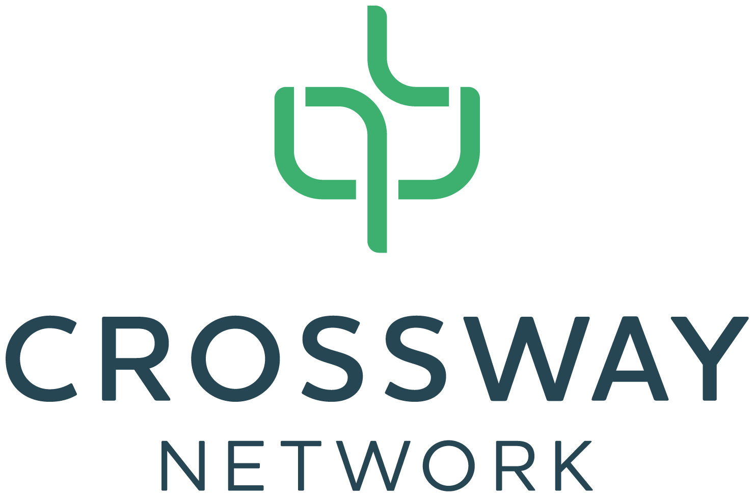

Crossway Network Ministerial Licensing
© Crossway Church Planting Network, August 2021
700 Automation Dr. Suite D, Windsor, CO 80550, (970) 674-5018

CrosswayNetwork.org

